Name: __________________________________ Date: ________________ Class: ___________ GRADE: ____________
Unit 3: Linear Functions Part 1

The graph below shows a relationship.  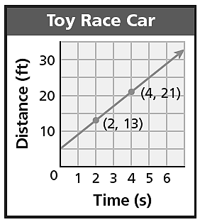  a) Create a verbal description of the relationship.  b) Is the relationship a linear function? How do you know?  c) How many solutions are there for the relationship? How do you know? | Graph the solutions to the equation $y=\frac{3}{2}x-4$.  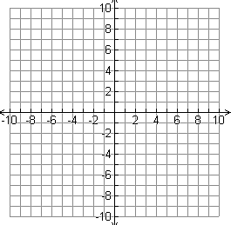  a) how do you know by looking at the equation that the relationship is linear?  b) how do you know by looking at the graph that the relationship is linear?
A hot air balloon rose from a height of 100 meters to 400 meters in 3 minutes. What was the balloon’s rate of change? | A student’s grade fell from a 96 to a 60 over 3 weeks because they slacked off and stopped doing their work. a) Create a properly labeled graph for this situation.  b) Using the graph, what is the rate of change?
Solve:  $$3(x+2)=2+3x$$ | What kind of number is $0.12345678909898765432101234…$?  How do you know?
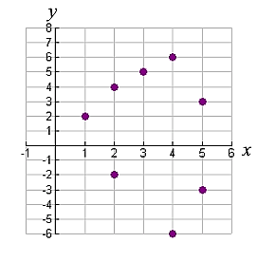  The graph below shows a relation.  a) Which point(s) need to be changed in order to make this relation a linear function?  b) Draw your changes from part (a) on the graph. | Over the summer you work walking dogs around your neighborhood. You decide to charge a flat fee for the service, and then an additional rate per dog that you walk. If you walk 5 dogs, you earn $18.00. If you walk 2 dogs, you earn $9.00.  a) complete the chart.  b) create an equation for this situation.  c) graph the situation.  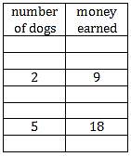  d) where is it appropriate to include arrows for this graph?

